University of Central Punjab, Lahore

Artificial Intelligence
BSCS
Assignment-02
CLO | CLO STATEMENT | Bloom’s Taxonomy Level | PLO
2 | To design and implement AI applications that solve real-world problems. | C3 | P3

Learning Objectives
- Apply and trace search algorithms (BFS, DFS, UCS, Greedy, A*) to solve problems and understand their execution process.
- Analyze and compare algorithm performance in terms of completeness, optimality, and efficiency.
- Evaluate heuristic functions and problem-solving approaches for selecting appropriate search strategies in different scenarios.
Instructions:
- Apply each search algorithm step-by-step as demonstrated in class, clearly showing the evolution of the OPEN and CLOSED lists, node expansions, and path selection.
- Provide proper reasoning for all analytical and conceptual questions. Answers without justification will not receive full marks.
- Assignment Type
This is an individual assignment. Each student must submit their own work.
- Plagiarism Policy
Plagiarism is strictly prohibited. Any submission found to be copied (from peers or external sources) will be awarded zero marks.
- Marks Distribution & Deadline
Deliverables | Due Date | Parts | Marks | Sub-Total | Total
Deliverable | Submission by 09:00 AM 10/11/2026. | Part A | 15 | 25 | 60
Deliverable | Submission by 09:00 AM 10/11/2026. | Part A | 10 | 25 | 60
Deliverable | Submission by 09:00 AM 10/11/2026. | Part B | 10 | 10 | 60
Deliverable | Submission by 09:00 AM 10/11/2026. | Part C | 10 | 10 | 60
Deliverable | Submission by 09:00 AM 10/11/2026. | Part D | 5 | 5 | 60
Deliverable | Submission by 09:00 AM 10/11/2026. | Part E | 10 | 10 | 60

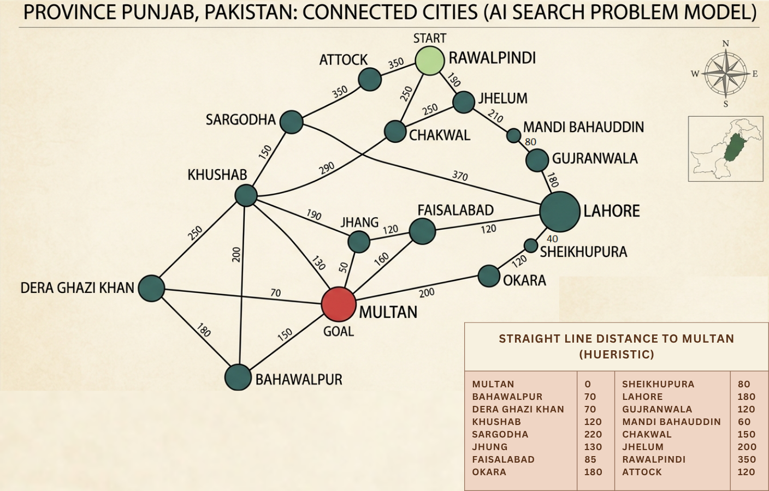
Part A: A* and Heuristics (25 Marks)
Q1. A* Execution (15 Marks)
Using above provided graph
Tasks:
- Apply A* Search
- Show:
  - f(n) = g(n) + h(n)
  - OPEN list updates
  - Final path
Q2. Heuristic Analysis (10 Marks)
a) Is the given heuristic admissible? Justify
b) Is it consistent? Justify
c) What happens if heuristic overestimates?

Part B: State-Space Problem (10 Marks)
Q3. Water Jug Problem
You have:
- Jug A = 4 litres
- Jug B = 3 litres
Goal: Measure exactly 2 litres
Tasks:
- Define:
  - State representation
  - Operators
- Solve using BFS (show steps)
Part C: Critical Thinking (10 Marks)
Q4. Algorithm Behaviour
Given a graph where:
- One path is very deep but cheap
- One path is shallow but expensive
Answer the following:
- Which algorithm prefers which path:
  - DFS
  - UCS
  - Greedy
  - A*
Explain briefly.
Part D:(5 Marks)
Q5. Debugging A*
A student computed:
f(n) = h(n) only
instead of:
f(n) = g(n) + h(n)
Task:
- Explain the mistake
- What algorithm does it become?
Part E: (10 Marks)
Trace the execution of the A* (A-Star) algorithm using the provided h(n) heuristic from LAHORE to ISLAMABAD.
- Show the state of the Frontier priority queue at each step, listing the f(n) values for each expanded node.


